Task Description #1 (Documentation – Google-Style Docstrings for  
Python Functions) :

OUTPUT:

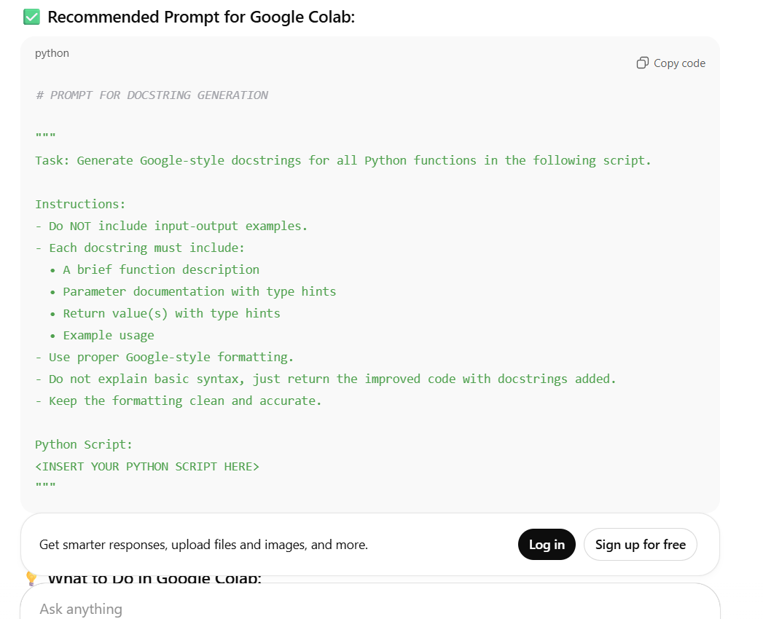

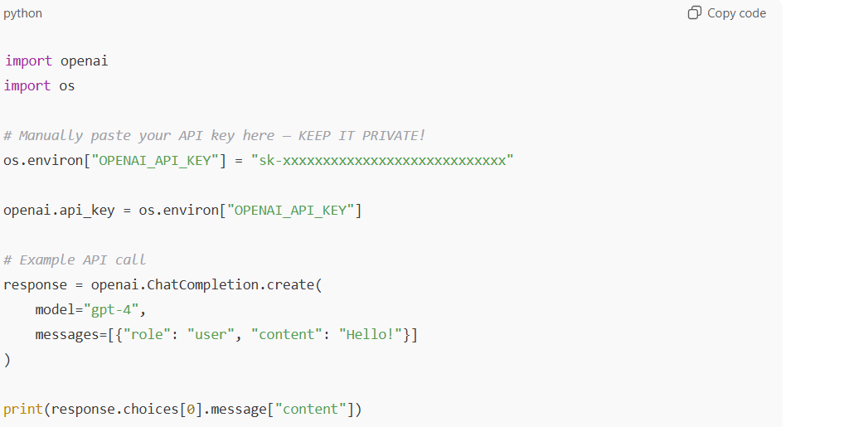

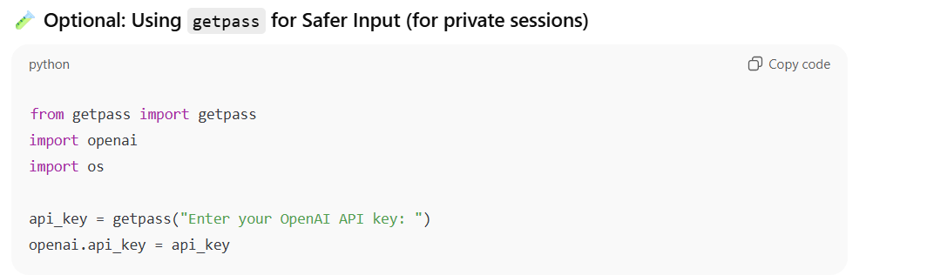

ITS SETTING API AND ARRANGING IT.

Task Description #2 (Documentation – Inline Comments for Complex  
Logic):

SOL: ENTERING THE PROMT IN CHAT GPT:

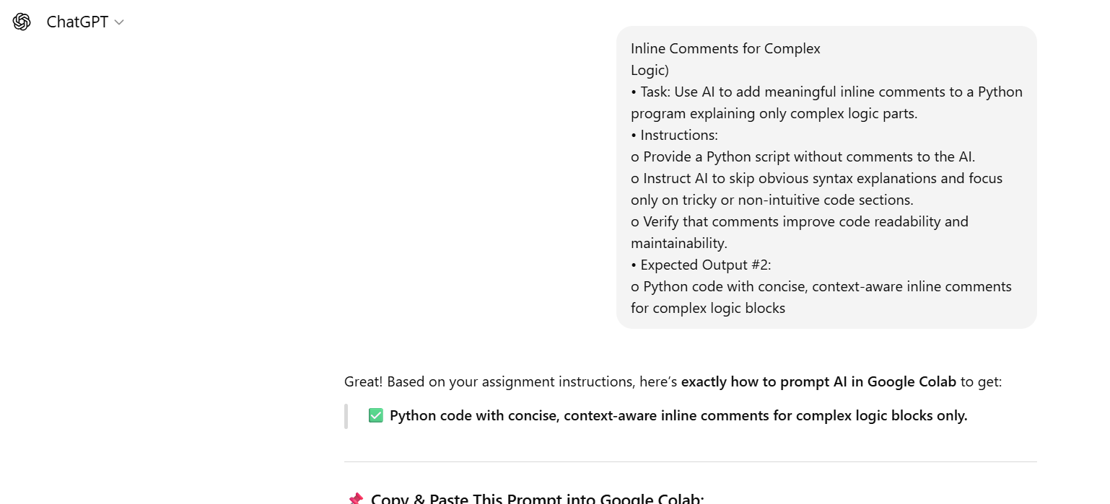

AFTER COPYING THE PYTHON CODE FROM CHAT GPT . NOW PASTING IT INTO GOOGLE COLAB

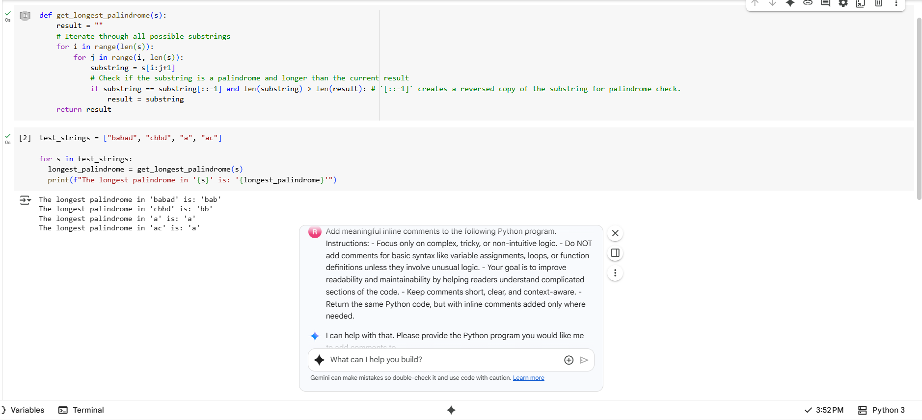

Task Description #3 (Documentation – Module-Level Documentation)

Sol: google drive link:

<https://drive.google.com/file/d/1qlnrS6G1Puj0o_xwwo2sdx4M-RBis6h2/view?usp=sharing>

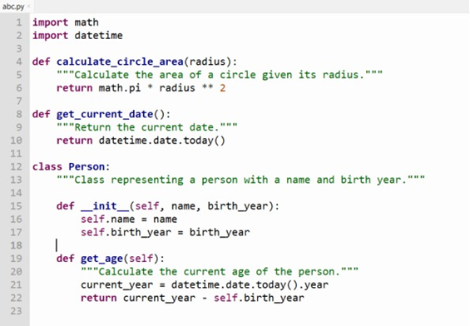

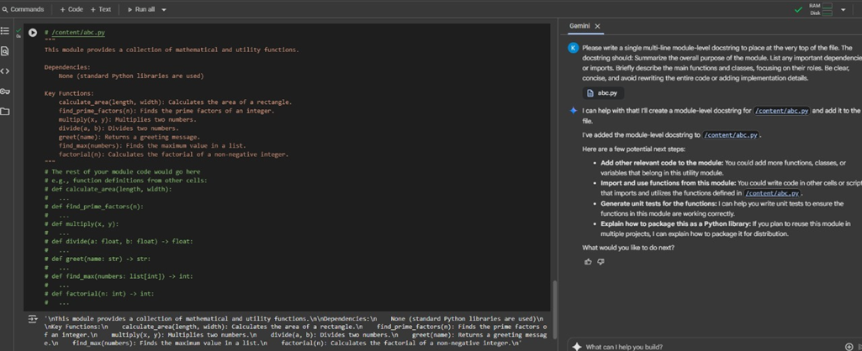

Task Description #4 (Documentation – Convert Comments to  
Structured Docstrings)

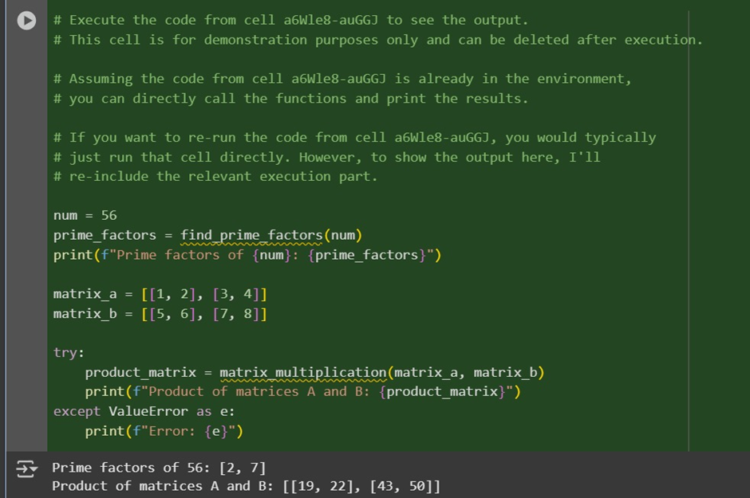

Task Description #5 (Documentation – Review and Correct  
Docstrings)

